Types of Grammar
# Source: Chatgpt (GPT-4-turbo) at [8/3/2025]
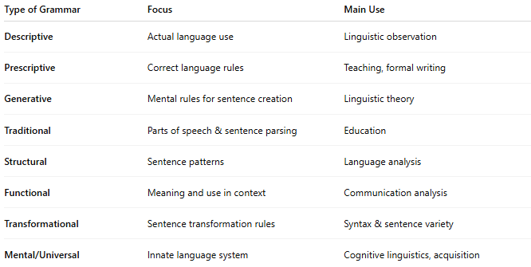

Type of Grammar | Focus | Main Use
Descriptive | Actual language use | Linguistic observation
Prescriptive | Correct language rules | Teaching, formal writing
Generative | Mental rules for sentence creation | Linguistic theory
Traditional | Parts of speech & sentence parsing | Education
Structural | Sentence patterns | Language analysis
Functional | Meaning and use in context | Communication analysis
Transformational | Sentence transformation rules | Syntax & sentence variety
Mental/Universal | Innate language system | Cognitive linguistics, acquisition

